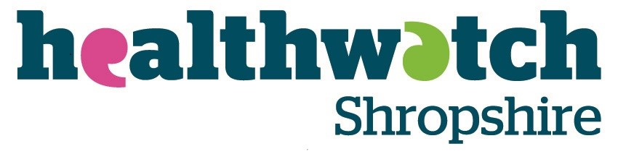

Minutes of Board meeting in public
1st September 2021

Minutes of Board meeting in public
Held via Microsoft Teams
1st September 2021.

Present: | Vanessa Barrett | VB | Chair
 | David Voysey  David Beechey | DV  DB
 | Anne Wignall  Terry Harte  Bob Welch  Lynn Cawley | ALW  TH  BW  LC
 | Steve Price | SP
Guest:  Apologies: | Jayne Morris  Roz Conway  Jane Turner Bragg  Dee Walker  Alli Sangster -Wall | JM  RC  JT-B  DW  AS-W
Minutes: | Patricia MacInnes  (Via recording) | PM

- Welcome, Introduction & apologies

RC and JT-B were introduced to the Board members

- Declarations of Interest

No new declaration of interest

- Presentation from Jayne Morris and Alli Sangster-Wall

JM gave a presentation on social media and an explanation on the work done on the Food Insecurity Project. LC presented the work done on Engagement HQ on behalf of AS-W.

- Board Meeting in Public held on 7th June 2021

        - Approval of minutes

Change of date and addition of SP as an attending member were done and a few typographic errors corrected.

Minutes were unanimously approved as accurate.

        - Matters arising not on the agenda

HWS CO gave an update on all the action points.

- Finance

- Management accounts to end June 2021

TH went through the Finance Report and explained some of the numbers.

It was confirmed that HWS is financially in a good position, but that discussion was needed to decide what to do with the surplus.

The Board received an update on the decision to recruit for a 34hrs a week member of staff and on the IHCAS consultancy hours.

The Board was informed that the Trustee Annual Report would be ready by the end of September and would have to be approved by the Board to be sent to the auditor.

On the topic of the Annual Reports, HWS CO reiterated the importance for volunteers and Board members to regularly send their volunteer hours for HWS to report an accurate number. An update on the Trustee Annual Report was provided and the Board was informed they would receive the draft shortly.

Discussion was had on the reserve previously agreed on by the Board and a potential project involving Young Healthwatch was explained.

The Board was also informed that it had been discussed for HWS to hold an annual event in quarter 4.

The vaccination of staff was also discussed and the need to ensure that any future member of staff is double vaccinated was reiterated. All board members were recommended to apply for a Covid Pass if considering doing face-to-face meetings or engagement such as E&V.

The Board was informed that the Business Committee had proposed for a small weekly amount to be spent to allow the team to do postcode mapping.

HWS CO provided an update on the restart of Enter & View visits and the need for Authorised representatives to have the Covid Pass as it will constitute a legal requirement for Care Homes from November and managers will not be allowed to let them in without a pass.

- Governance

- Risk management matrix

It was suggested to reconvene a group to update the risk matrix for the current year. Several Board members volunteered to be on this group (VB, DV, AW and SP)

ACTION: HWS CO to send a doodle poll to organise a meeting for the risk matrix review.

Regarding the risks linked with the Ockenden Review, the Board was informed that the Police had contacted HWS but the Ockenden Review team have not. No one had so far suggested that HWS had missed warning signs regarding the safety of maternity services in Shropshire. An update on the report and the current situation of maternity in Shropshire was provided.

- Board recruitment

Steps taken to recruit new Board members were discussed.

- Reporting

- Chairs report

No question was asked.

- Chief Officer’s report

HWS CO summarised key points of the report.

An update on the phone, video and online appointments report and its presentation to the Health and Well Being Board was provided.

The phlebotomy report was discussed, and the Board received an update on the ongoing work on the topic. It was reiterated that HWS would argue for the equitable access to phlebotomy throughout Shropshire.

The number of priorities for HWS to work on was discussed and HWS CO explained how HWS was being involved in the various pieces of work and how the work was being organised.

The work on dentistry and expected answers to HWS report was discussed.

An update was provided on the piece of work on Perimenopause, menopause, and post menopause.

The Board was informed that HWS would be revisiting the Urgent Medical Care survey following the report published in May 2021 at the request of the CCG.

An update was provided on the work done around MSK, including the progress of the survey that has moved from EHQ to the website.

The Board was also informed of the coming meetings to be attended by HWS.

- Committee report

The Board was informed that the Marketing and Engagement Committee had met and agreed on new Terms of References and about what the committee would be working on. The committee Chair gave a summary on a discussion had about HWS next annual event; HWS CO updated the board on the possible piece of work to promote Patient Groups. CO also explained HWS involvement in the system End-of-Life Group and the three working groups. One of these is “Growing the conversation”. It was suggested that HWS could use the annual event to support the work to encourage people to talk about death and dying and run a ‘Death café’. It was requested for the CO to present a proposal on that suggestion for the Board to look at.

ACTION: HWS CO to offer a proposal on using HWS annual event to promote discussion around End-of-Life care

- AOB if notified in advance

No other Business raised

- Questions from the Public

No questions raised

- Resolution to manage confidential business in a closed meeting

