**Healthwatch Shropshire Chief Officers**

**Report to the Board**

**February 2021 – May 2021**

**Introduction**

Gathering and understanding people’s experiences of using local services is fundamental to informing the activities of Healthwatch Shropshire (HWS).

As well as continuing to deliver on our statutory functions, our priorities for 2020-21 are:

* Mental Health (all age mental health)
* Community and Place Based Care (including Primary Care, Care Homes, Home Care and prevention)
* Acute Care (including Acute Hospital Reconfiguration, Transforming Midwifery Care)
* Workforce (including recruitment, training and support - such as access to PPE)
* Digital (how technology is being used across health and social care, particularly during the pandemic)

For our activity in **Quarter 4 (January - March),** please see the KPI document.

**Forward Plan 2021-22**

At the time of writing this report we are in the process of contacting individual stakeholders to encourage them to complete our Feedback Survey to form part of a 360o audit. Our timing for this piece of work was not ideal as the CCGs became one strategic commissioner from 1st April 2021 and a number of people left the system, including the Accountable Officer and Chair. The ongoing pandemic also means that a number of people are still not performing their usual roles, e.g. they are currently involved in the vaccine rollout.

As part of this survey we also asked people to share their ideas for areas of focus for HWS in 2021-22.

The draft Forward Plan will be shared with the Board in June 2021.

**Report**

1. **Intelligence**
   1. Hot Topic Update

* July – September 2020: Telephone and online appointments

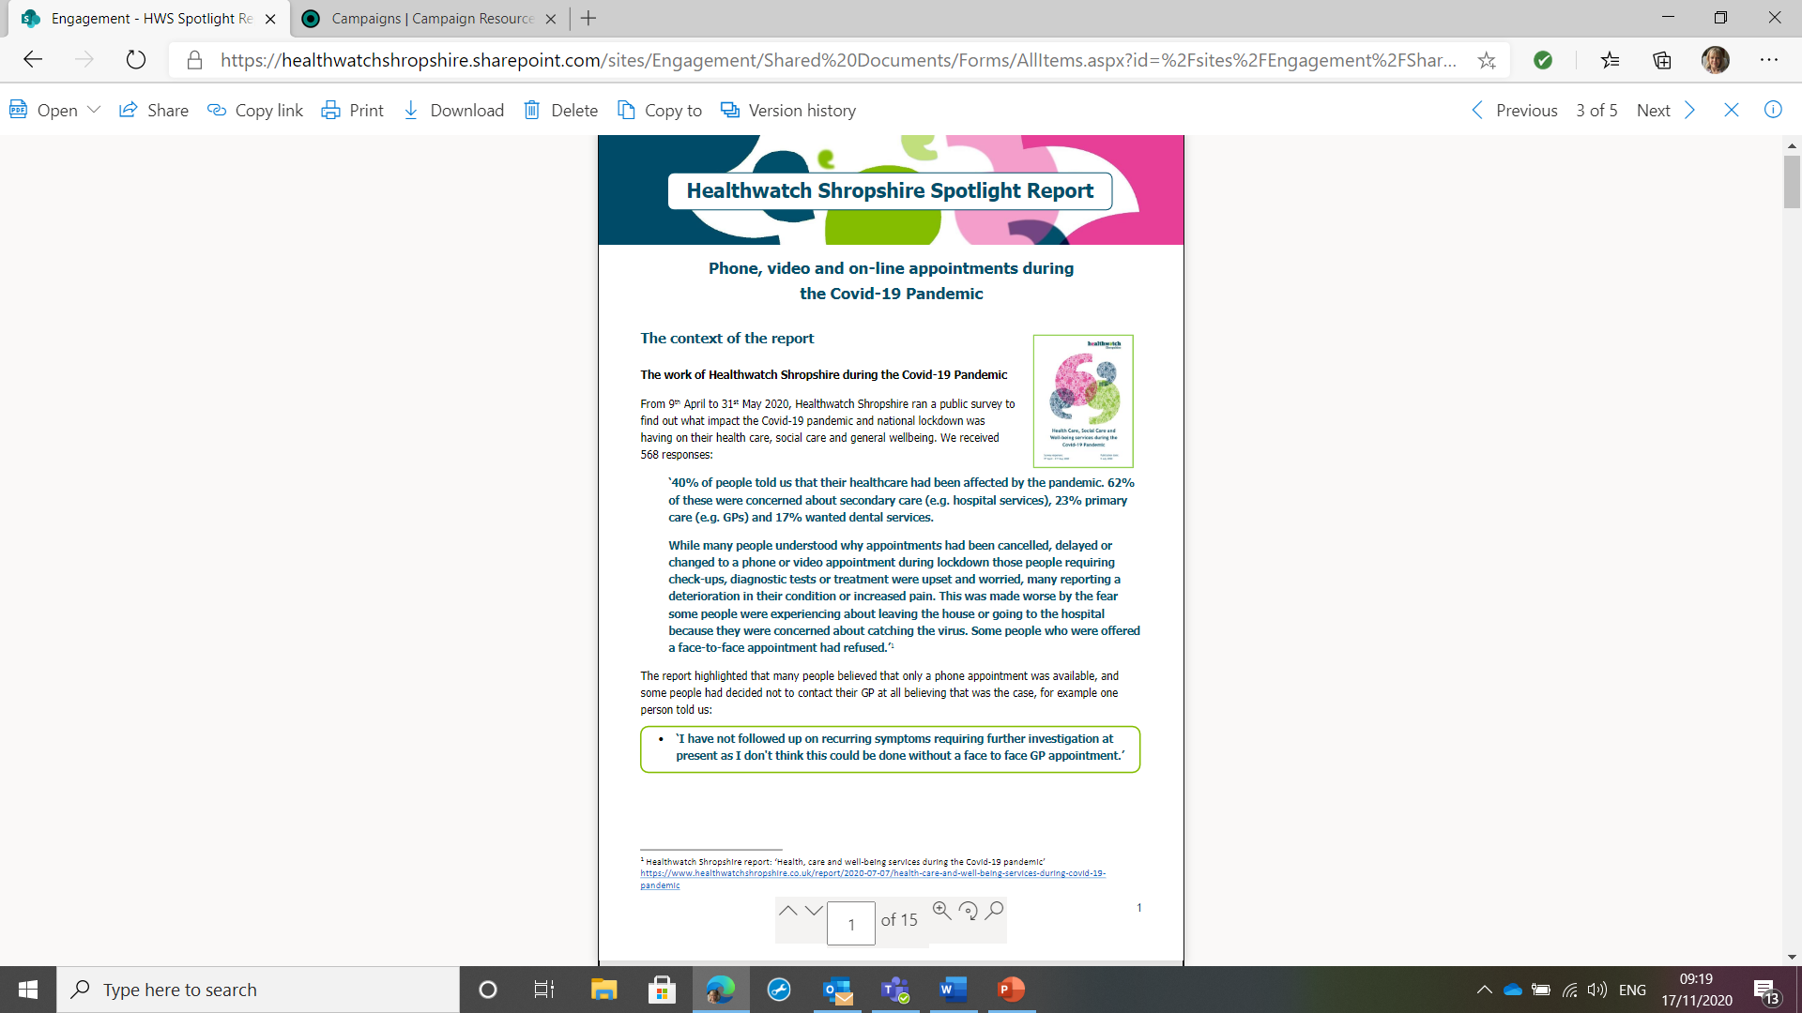

Following the recent elections and the two CCGs coming together from 1st April 2021 the membership of the Health and Wellbeing Board has changed (there will be a new Chair, Vice-Chair and portfolio holders).

The next meeting is planned for July 2021 and the CO has been asked to present this Spotlight Report as the current focus of the health and social care system is health inequalities including digital inequality and the potential impact of the NHS in particular relying on virtual appointments either by phone, video or email.

* September – December 2020: Phlebotomy and Covid-19 Public Messaging

Both of these activities continued into 2021. Our Engagement Officer engaged with the CCG on their Phlebotomy Engagement Plan including attending weekly meetings and HWS helped to promote the survey. We have also continued to share the most up-to-date Covid messaging using our social media channels.



* December – January 2021 Visiting during the Covid-19 Pandemic

At the end of November we launched a Hot Topic to gather people’s views about the visiting restrictions during Covid. We specifically wanted to hear about the solutions some providers had found to help improve communication between patients/service users and their families/carers, e.g. purchasing iPads, installing visiting pods and creating Covid secure rooms with Perspex dividers to allow people to see their loved ones. We also asked people to share any ideas they had that hadn’t been tried yet.

We received a low number of comments (5 about hospitals and 10 about care homes). We thought that this was probably due to the timing of the hot topic as many people’s attention had moved towards the vaccine rollout and the possibility of lateral flow testing being used to enable a small number of visitors to go into care homes.

The report will be available on our website when it is completed.



1.2 Current Hot Topics

* February – *Ongoing* Covid-19 Vaccinations

At the beginning of February we launched a Hot Topic to gather people’s experience of the Vaccine rollout as we had received a number of comments showing a range of experiences across the County (e.g. some areas seemed to be slow to move between priority groups, some people reported being directed to clinics outside Shropshire). HWE had also asked local HW to gather comments.

As well as gathering feedback in the usual way decided to add a survey created by Healthwatch England to the Engagement HQ platform:

<https://healthwatchshropshire.uk.engagementhq.com/covid-19-vaccinations>

It is hoped that because the vaccine affects everyone it will increase the number of people looking at the platform and hopefully encourage people to sign-up. All comments will be shared with Healthwatch England and help build the national picture.

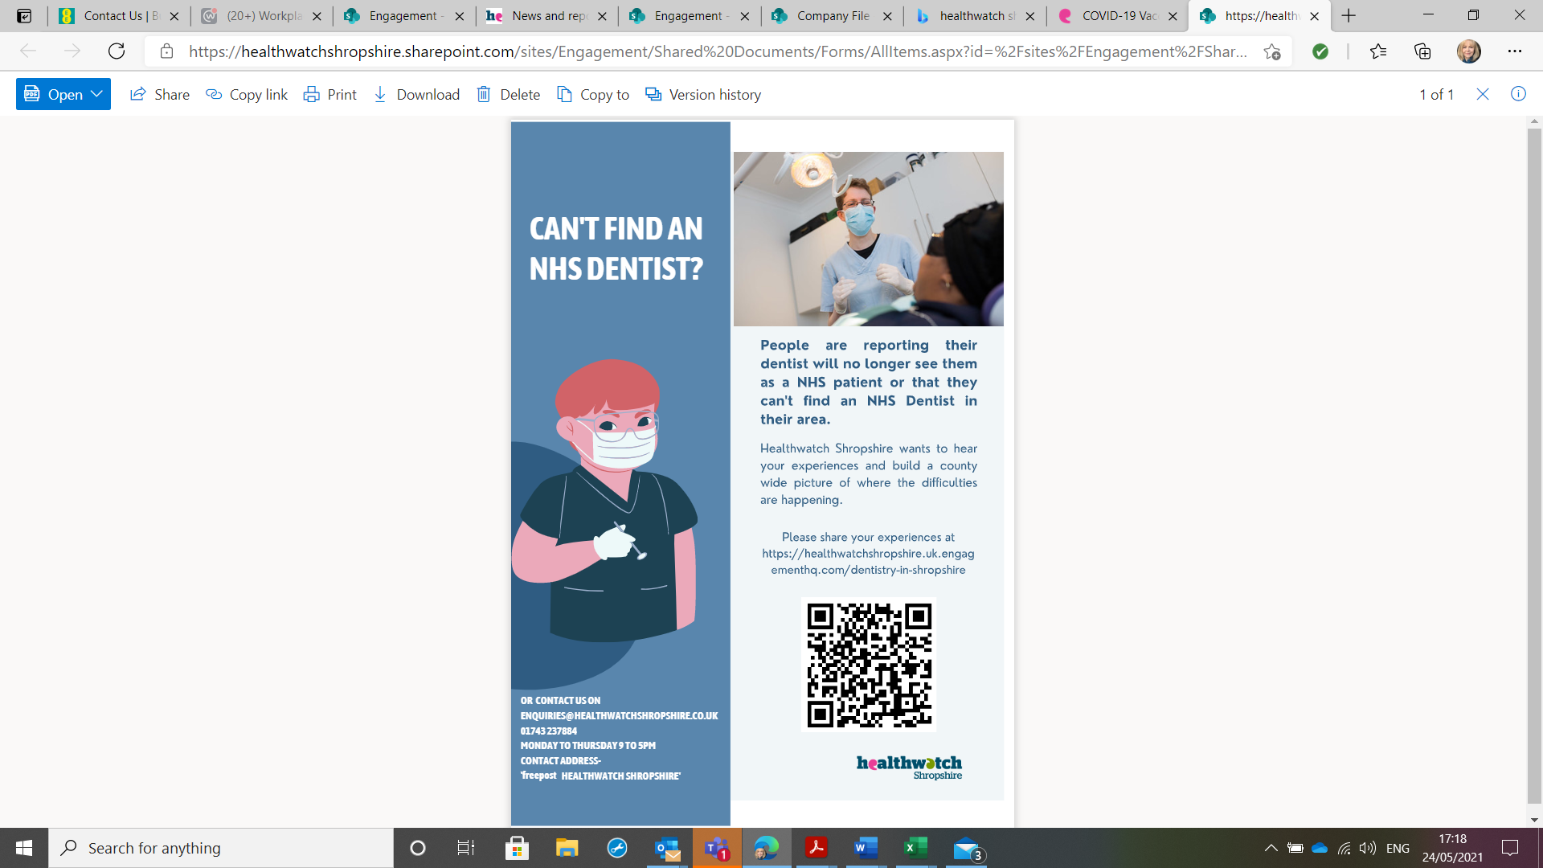

* May – July Access to NHS dentistry

HWS receive a steady stream of comments about access to NHS dental services. As practices either closed, reduced the range of services or their capacity due to social distancing and cleaning regimes during the pandemic we received more. One of the reasons for this is that on the NHS England website where you can find an NHS dentist it states: *‘Your local Healthwatch may be able to give you information about services in your area or raise a concern if you have one.*’ This means that people think we can find them a dentist but all we can do is direct them back to the information on the NHS website which is often out-of-date. This leads to anger and frustration.

<https://www.nhs.uk/nhs-services/dentists/how-to-find-an-nhs-dentist/>

As part of this piece of work we plan to engage with the Local Dental Committee to understand how many local dentists they represent. Going forward we would like to work with the LDC to ask practices to let us know when they have NHS spaces so we can keep a live spreadsheet. We hope the volunteers could also get involved by regularly phoning around practices for updates. This is something that other HW are doing in order to better fulfil their signposting function.

We regularly share comments about dentists with the commissioner, NHS England. In the past we have also highlighted areas where there was an issue and NHSE commissioned additional NHS capacity.

As well as contacting us in the usual way people can go onto Engagement HQ where we are using the map function so people can tell us where they live and where the issues are:

<https://healthwatchshropshire.uk.engagementhq.com/dentistry-in-shropshire/maps/shropshire-dentist-access>

* June – July Pain Management Services (MSK)

Musculoskeletal (MSK) services are one of the Integrated Care Systems ‘Big 6 ticket items’ for 2021-22. The way these services are delivered is changing and so far members of the public have not felt sufficiently involved in discussions about the changes.

A range of services come under MSK and so a lot of people will be affected. The team agreed that this could be a good way to support the system to hear from a wide range of people while also demonstrating to the public (and the system) what Engagement HQ can do. We have met with the clinical lead and commissioner for MSK on a number of occasions and made proposals for how engagement could be conducted on the platform. While waiting for approval from the MSK Alliance HWS has decided to focus on Pain Management Services. These services are due to go up for re-tender in March 2022 so it will be an opportunity to get feedback on the services and follow up on the recommendations we made following a series of Enter & View visits to clinics in 2017.

To read the report published in 2018: <https://www.healthwatchshropshire.co.uk/report/2018-01-30/inhealth-pain-management-solutions-enter-view-visit-report>

* 1. Surveys and hearing from seldom heard groups

We are very conscious that our priority remains hearing from the vulnerable and seldom-heard so we continue to work to ensure that our hot-topics and surveys are widely publicized and people are given our phone number so that the team can complete surveys with them over the phone if necessary. We ask partners from across the STP and our stakeholders to help us promote our work and support people to contact us if necessary. We continue to highlight our Freepost address, e.g. for the Vaccine Hot Topic.

Each time we launch a new piece of work we produce a press release. These are frequently picked up by BBC Radio Shropshire and the CO has been invited onto the Breakfast Show on a number of occasions. We give out our phone number and this usually leads to an influx of calls. This is a really useful way for us to reach those people who do not have access to or use the internet.

Recent surveys:



* **Hospital Discharge during Covid-19**

Healthwatch England, working with NHSE/I, launched a national survey to gather people’s experience of discharge during the pandemic. It was due to finish late August. Rather than promote this survey we decided to run our own survey, which would allow us to work with our providers to develop the questions to make sure they would result in the most relevant and useful feedback and agree a timescale that would suit the local system. We worked with HWT&W to develop the survey. It was hosted on the HWS website.

Initially it was agreed that all Telford & Wrekin responses would be sent to HWT&W so they could produce their own report but due to the low number it was agreed that HWS would include all responses in one report.

When we shared the draft report with providers they informed us that the survey had been completed by people who had not gone through the discharge process introduced during the pandemic and so would not have been eligible for the post-discharge support from the Integrated Discharge Hub. We reminded them that we had asked them to promote the survey to the relevant patients and their families.

The report was published 11th March 2021:

<https://www.healthwatchshropshire.co.uk/report/2021-03-11/hospital-discharges-during-covid-19-pandemic>

* Urgent Medical Care



HWS offered to lead on this survey after the CO was involved in a number of meetings where the CCG said they wanted to know if people were aware of NHS 111 First (launched December 2021) and to understand why so many people are still going to A&E. As with recent surveys covering the STP footprint (Out of Hours Palliative Care, Discharge) the CO spoke to HWT&W who were in support of a joint survey. Our Information Officer (IO) worked with the CCG to develop the survey which could be completed by a range of people including patients. The number of options means that this has been the most complex to build on the website and the IO spent a number of hours supporting HWT&W to build it on their website so they could go live simultaneously.

The report was published 18th May 2021 without a comment from the ICS. This will be added when it is received but we did not want to postpone publications:

<https://www.healthwatchshropshire.co.uk/report/2021-05-18/experiences-urgent-medical-care-shropshire>

**UPDATE:**

At the Urgent and Emergency Care Delivery Board on 25th May 2021 a presentation was shared that is being submitted to NHSE as part of the system’s ongoing monitoring of NHS111 First. Our data was a key part of the presentation supported by system data and a survey of staff.

Current and future surveys

* Workforce survey

The CO and IO met with ICS Programme Manager for People on 8th April 2021.

**2 Communications and engagement**

2.1 Engagement activities

We continue to wait for guidance from HWE about re-starting face-to-face engagement. The CECO joined a HWE Engagement Leads Update meeting to discuss this 26th May 2021.

In the last report I explained that the CECO had contacted agencies currently involved in engaging with schools and colleges to hear from students about their experience of Covid-19 and its impact on their health, wellbeing and education to find out if there is a role for us and what contribution we can make. We did not receive a response and so prioritised other work.

2.2 Engagement & Marketing Committee

Due to the amount of time the CECO had to commit to the Shaping Places, Healthier Lives Project the first meeting remained on hold in Q4. The CECO will contact the Chair to arrange an initial discussion in order to draft the Terms of Reference and agree the agenda.

2.3 Funded projects

* **Shropshire Council – Shaping Places, Healthier Lives (January – April)**

The role of HWS has been to lead on engagement with the public and partners around food insecurity in South West Shropshire. Findings will be used to submit a bid for further work across Shropshire to improve access to affordable, healthy food.

|  |  |
| --- | --- |
| **The contract required us to** | **Update** |
| Work closely with the Shropshire Food Poverty Alliance (SFPA) to plan and implement the engagement process including surveys and develop the interview schedule and sampling framework |  |
| Work with the SFPA to arrange initial meetings with key organisation in each town (including Foodbanks) to discuss the project, including the best method for engagement locally |  |
| Interview people in South-West Shropshire who have lived experience of food poverty and collate and report on the findings to the Project team |  |
| Be the lead contact for people (public, partners) who want to engage with the project |  |
| Plan and co-facilitate 5 Zoom discussions as part of the engagement process and follow up with key organisations if they can't attend, to ensure their views are included |  |
| Develop a communications strategy so target communities and partner agencies are engaged and informed of progress |  |
| Host the webpage and on-line survey |  |
| Compile the survey results |  |

The original timescales changed and so the CECO has continued to work on this project into May-June to complete the report and support Public Health in their presentations to the commissioners of the project.

* **Healthwatch England Digital Engagement Pilot Project (February – July)**

Earlier this year we were successful in our tender to trial an online engagement platform for Healthwatch England (HWE). During the pandemic all face-to-face engagement ceased and so we had to turn to on-line engagement tools including our website and social media platforms. The HW network is aware that dependence on online tools is not ideal and will not enable us to fulfil out statutory functions but engagement platforms are being increasingly used by health and social care systems as they bring together a number of engagement tools, e.g. surveys, polls, online forums and chats. The trial runs until the end of July.

The view of the CO is that local Healthwatch should host platforms like this and then work with providers and the health and social care system to facilitate dialogue with the public. This then gives us oversight of that dialogue and the opportunity to shape it while also encouraging and promoting meaningful public engagement. The concern is that individual organisations like the CCG will get their own platform and this will lead to us all competing for public interest and potentially lead engagement fatigue.

Details of how we have used the platform so far have been highlighted in this report.

2.4 Partnership working

* The Integrated Care System (ICS)

Nicky O’Connor the ICS Programme Director has been invited to given un update on the development of the ICS as the Board meeting 7th June.

The ICS Board moved from ‘shadow’ status on 1st April 2021 formally replacing the Sustainability and Transformation Partnership (STP). This means all STP meetings have become ICS meetings. For more information on what an ICS is go to:

<https://www.england.nhs.uk/integratedcare/what-is-integrated-care/>

The CO has been prioritizing building relationships with leaders across the ICS in order to ensure HWS are involved in the right meetings and part of discussions at an early enough stage for us to plan public engagement around emerging issues. It is hoped that by doing this we will be able to bring the public voice to the attention of the system and they will recognise HWS as a valued partner in public involvement and engagement.

* Meetings with providers and regulators

Quarterly meetings are in place with:

* CCG Patient Experience Lead – at the moment the CO is also attending meetings led by the Lay Member of the Board responsible for public involvement about developing the systems approach to involvement and a more consistent approach to responding to compliments, concerns and complaints across the ICS
* SaTH Patient Experience Lead
* Director of Adult Social Care and Commissioners for Care Homes and Domiciliary Care
* CQC Inspectors for Adult Social Care, SaTH, MPFT, SCHT (ShropComm) and Primary Care

Meetings with other providers are arranged when we have information to share. At the moment these meetings continue to take place over MS Teams or contact is made by email, e.g. MPFT, RJAH, SCHT.

Due to the increasing number of comments we have received about dentistry during the pandemic the ICO has contacted NHSE more regularly to share comments and ask for updates about service provision.

2.5 MLU Review and Consultation

As reported at the last Board meeting the consultation remains on hold and we are awaiting notification of when the consultation will start.

**UPDATE:**

**3 Enter & View**

3.1 Current status

As for public engagement, Enter & View visits remain on hold.

3.2 Reports



Volunteers were involved in a Care Homes Digital Audit which involved looking at the websites of all 120 care homes in Shropshire and completing a checklist of what information was available online. We also looked at the Facebook pages of 30 care homes, chosen at random, to see what use care homes were making of social media, e.g. when visting was not permitted during the pandemic.

The report was published on our website

23rd March 2021.

<https://www.healthwatchshropshire.co.uk/report/2021-03-23/digital-audit-care-homes-shropshire>

**4. Information Requests**

4.1 Maternity Services at SaTH

As a member of the LMNS Board and CCG Quality and Performance Committee the CO has had sight of SaTHs response to the Ockenden Report and given feedback in particular around the need to listen to women and families.

The CO and Chair of HWS are on the Ockenden Assurance Committee. This is a monthly meeting where SaTH describe the actions taken in response the Ockenden report and future plans. The first meeting was held 25th March 2021.

**5. Staffing and IT**

5.1 Staff update

A staffing proposal was presented to the HWS Business Committee on 24th May. We are awaiting costings from the Finance Officer.

5.2 IT and phone system update

All staff are continuing to use their work laptop to support home working and are becoming familiar with SharePoint. We had a meeting on 13th May to work through some problems team members have experienced and share work arounds.

As reported at the last Board meeting, we have received no update from the RCC on their plans to move to an online phone system. We have asked to be included in any quotes they get and approached our IT provider for a quote in case we decide to do something different as our needs are slightly different regarding the interplay with our IT system.